Biosciences Seminar
in collaboration with
Vijnana Bharati
Under the
The Microbiology and Biotechnology departments of VES College of Arts, Science and Commerce, in collaboration with Vijnana Bharati, organized a two day seminar on “Biosciences - an avenue for a better tomorrow” on 17th and 18th February, 2018. The seminar was financially supported by the Star College Scheme of the Department of Biotechnology (DBT), Government of India and HiMedia Pvt. Ltd. The seminar included talks by eminent scientists and industry experts who introduced the students to the latest research and technologies in Biosciences. The program was attended by 140 students and 12 staff members from various colleges of Mumbai.

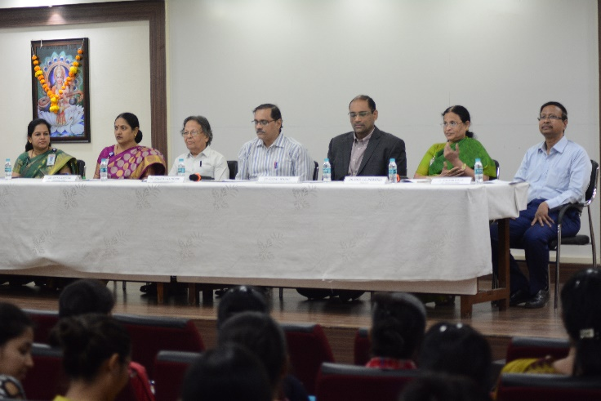
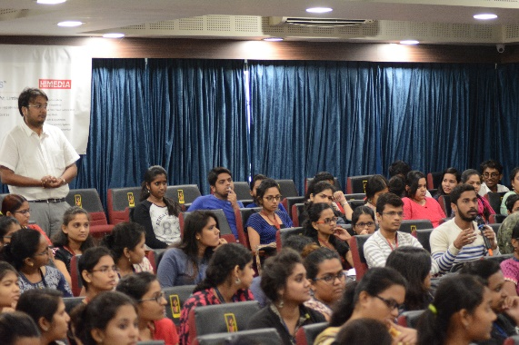
The programme started with an inauguration ceremony which was attended by Dr. Rajware, Secretary, and Dr. Bhave, Vice-President, Vijnan Bharati. The chief guest for the ceremony was Dr. Vishal Warke, Director, R & D, HiMedia Laboratories. He spoke about "Recent Advances in Vaccine Production and Hydroponics". He shared the idea behind setting up HiMedia and the struggles faced by the company to become a name of international reckon. He then presented career options that a budding microbiologist/ biotechnologist could select. He promoted the idea of bio-entrepreneurship. He stressed on the diversity covered in the field, and how that can lead to generation of a wide variety business ideas. His talk was very informative as he introduced "Hydroponics". Hydroponics is a subset of hydroculture, the method of growing plants without soil, using mineral nutrient solutions in a water solvent. Terrestrial plants may be grown with only their roots exposed to the mineral solution, or the roots may be supported by an inert medium, such as perlite or gravel. He explained the applications and significance of Hydroponics in Indian agriculture and also stressed how this alternative can be used as a business idea. He explained how hydroponics can bring about the next agricultural revolution by vertical farming, and improvement in crop quality.
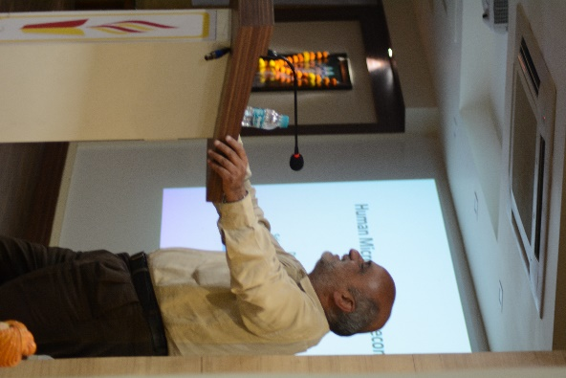
This was followed by a talk by Dr. Yogesh Shouche (Scientist, NCCS, Pune) on "Human Microbiome". He is the head of the culture collection centre at NCCS Pune. His is the largest culture collection in the world. Dr. Shouche introduced the students to the concept of Microbiome and explained the importance of microbial diversity in normal flora of humans. Microbiome is a collection of data on all the micro-organisms that inhabit a particular environment. He explained how the microbial floura of humans vary from individual to individual and can be used as a unique signature for each individual. Since the microbiome of an individual would depend on their diet and food habit, microbiome can be as specific to an individual as genes, and can therefore be used for population studies. He showed date on how the microbiome of Indians is significantly different from that of Americans. He elaborated how this microbiome is important in defense against diseases like Diabetes, mental health etc. His talk made students question about the significance of microbiome, probiotics, and impact of microbiome on human behavior.
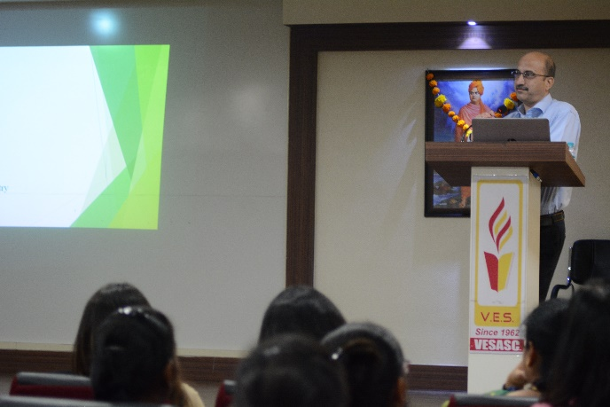
The first talk in the post-lunch session was by Dr. Sunil Apte (Section Manager, Microbiology and Food Safety, Mondelez International) entitled "Food Safety". Dr. Apte has vast experience in food safety and he helped students understand the importance of Good Manufacturing Practices (GMP), and Personal Protective Equipements (PPE) in food production and maintenance of food quality. He also explained about the ways to tackle issues faced by food industry in cases of physical, chemical or biological contamination of their products. He cited various examples of leading food manufacturers who had faced heavy lawsuits due to various adulterants found in their food items. He informed the audience about how these companies dealt with these problems, sometimes calling back an entire shipment of orders, to changing an entire production plant. This helped the students understand the importance of quality control in food industry and also the responsibility of a food manufacturing enterprise.
The day ended with a talk by Dr. Vinay Deshmukh (Ret. Principal Scientist, Mumbai Research Centre of CMFRI) on "Coastal ecosystem, biodiversity and resource managemant"
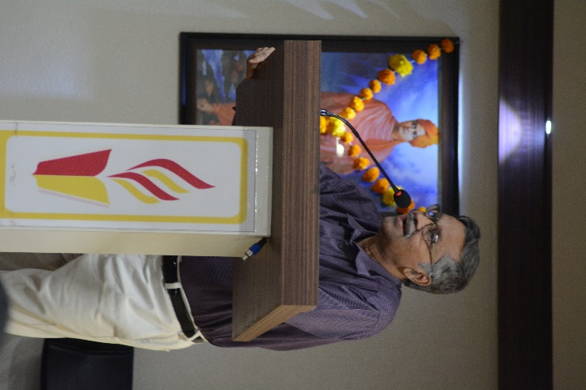
Dr. Deshmukh cleared the basics of marine biodiversity, and explained the coastal ecosystems briefly. Topics like, biosphere, ecosystems, biodiversity and role of biodiversity were discussed. He showed magnificient pictures of the aquatic flora and fauna that helped the audience understand the magnitude of life below water. His talk covered the reasons for deterioration of marine ecosystems and also emphasized on the gravity of the current situation for aquatic ecosystems.He ended his talk by suggesting a number of ways to protect aquatic life which I more diverse and widespread than the life on land.
Day two started with a walk through the industrial microbiology textbook, with a talk by Dr. B.V. Vakil (Adjunct Professor, Guru Nanak Institute of Research and Development, G. N. Khalsa College) on Advances in fermentation technology. He spoke about the latest technical progress in the field of instrumentation of fermentation. He explained how the textbook designs of fermenters and fermentation technology are no longer in use. As a very competitive and burgeoning industry, the field of food fermentation technology is coming up with advanced models and accurate monitoring systems every day. He showed pictures and explained concepts of new fermenters that are currently in use. He spoke in detail about every part of the fermentor and how the upgradation of each and every part, such as the mechanical seal, impellars and filters, leads to the upgradation in the fermentor design. His talk emphasizd on the significance of instrumentation and technology is a field of basic sciences such as microbiology. It was a wonderful way to put forth the wholistic and multi-disciplinarydisciplinary nature of the fermentation industry. He also delved into the monitoring, controlling and data logging methods adopted today by the industry. He emphasized on the importance of correct data logging and analysis and the significance of the data generated. He ended his session with a short preview into expectations of the industry from students who intend to join the same. He spoke about the various roles that exist in the industry and what are the minimum requirement of each of these. This was very informative and inspiring to the students, the future microbiologists and biotechnologists.

The next talk by Dr. S. A. Angadi (Professor, School of Medicine & Health, DY Patil University, Navi Mumbai) was on Bioterrorism, an intriguing topic that fills our minds with questions and hearts with anxiety. His talk was like a walk through the story of microbiology. He started by talking about Leuwenhoek, the invention of the microscope and the discovery of the life forms, invisible to us, the microbes. He then went on to explain how microbes gained significance because they harmed human health and then later because they could be used for human benefit. His talk covered fields that developed because of microbiology, such as vaccine development and antibiotic design and production. After he went through the glory that microbiology as field achieved in the field of human health and medicine, he ventured into how, now that we know a lot about these organisms we can used them to cause damage to human life, as biological weapons. He enlisted various pathogens which have now been supposedly eradicated from the planet due to effective immunization programs, such as small pox and plague. Since the pathogens have been eradicated, the current population is not vaccinated against them, and thus are vulnerable to infection, thus the threat of bio-terrorism. His talk had the feel of a thriller movie that kept the audience gripped to their seats and also made them understand how knowledge in the wrong hands can have sinister consequences.
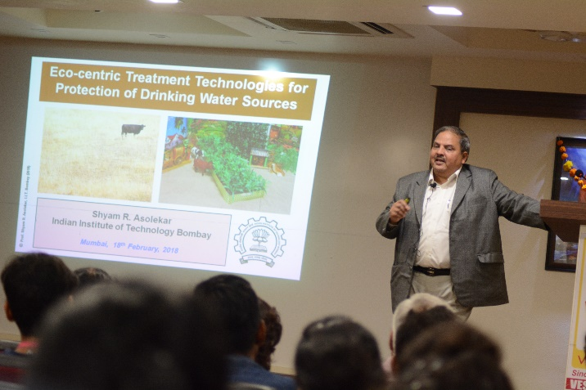
This was followed by a very stimulating talk by Dr. Shyam Asolekar (Prof. IIT, Bombay) on “Environmental Biotechnology”. Dr. Asolekar talked about his work around Powai lake and how he is trying to maintain and enrich the biodiversity in that area. He also had many interesting pictures to show which kept the audience rapt. He inspired all with his description of a constructed wetland treatment system developed by his team at IIT. He elaborated on the need for social consciousness among science graduates and sensitivity towards the severe challenges faced by poor farmers, who comprise 70% of our country’s population. He stressed on how science should now work on upliftment of the conditions of the poor and how that would trul help in the development of the country.
The last talk of the seminar was delivered by Dr. A B Pandit (UGC Prof. ICT, Mumbai) on “Intensification of intracellular enzyme recovery”. He talked about utilization of natural resources since nature makes the best reactors. Enzymes, the natural machines can be used to improve efficiency of many industries. His talk covered protein purification in detail starting from gene cloning, to expression and different techniques of purification. He detailed on new methods of purification using cavitation technique. It provided insight into use of biophysics in protein purification. He also covered study of enzyme activity and yield.
The two-day seminar covered a huge diversity of subjects in biotechnology and microbiology and provided a bird’s eye view into the various fields of research in these fields. Talks by the industry experts also exposed students to the application of biological research. Talks on biodiversity and environmental biotechnology sensitized the students to the need for research to increase sustainability on the planet. The students were very intrigued by all the talks as each and every one of them taught them a new dimension about their field of study. The seminar was held under the Star College Grant provided by Department of Biotechnology, Govt. of India.

