Teacher Training Workshop
on
HUMAN GENETICS
Sponsored by LTMT (Lady Tata Memorial Trust)
In association with IWSA (Indian Women Scientists’ Association)
An understanding of human heredity is of critical importance in the prediction, diagnosis, and treatment of diseases that have a genetic component. Human genetics research generates knowledge with the potential to improve individual and community health. Though the workshop was to train the teachers, one of the parallel goals was to encourage students to think in terms of these relationships, between humans, their environment and their community at large.
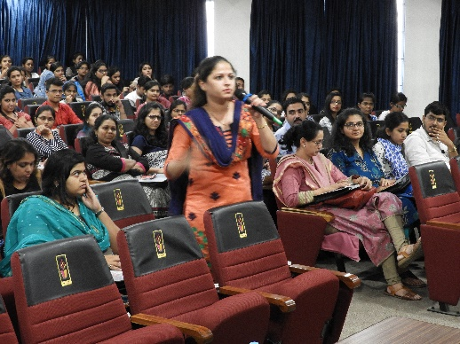
The workshop was organised for teachers from all over the state of Maharashtra. The lectures, however, were open to all, teacher participants and interested students of under graduation, post-graduation and doctoral studies from the field of biosciences. We received an overwhelming response for the workshop with registrations from 30 teacher participants from 22 different colleges affiliated to 9 different universities/Institutes. There were 7 outstation participants from Pune, Nashik, Nanded, Aurangabad and Osmanabad.
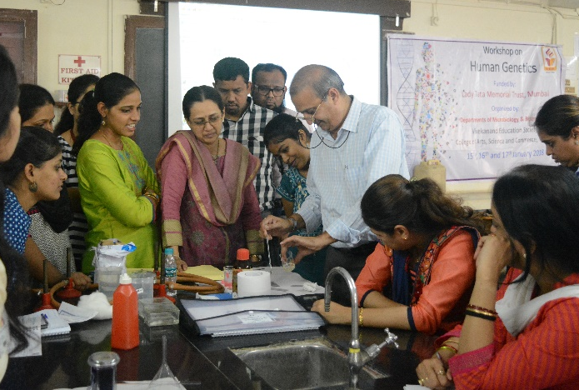
The keynote address on Human chromosomes and review of recent advances in clinical genetics was given by Dr. Jayarama S. Kadandale, Professor and Head, Clinical and Molecular Cytogenetics, Centre for Human Genetics. Dr. Jayarama gave us a complete overview of conventional and modern diagnostic tools in the analysis of human genetic diseases. Starting from the basics of the structure of human chromosome he explained the importance of various techniques used to study human genetics.
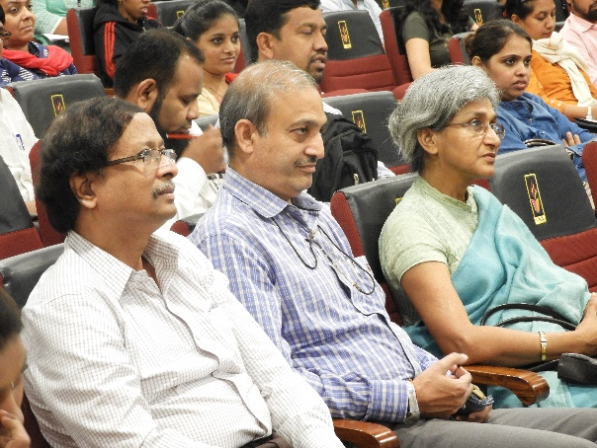
The speaker for the first session of day one was Mr. N. K. Sharma, from Bhabha Atomic Research Centre(BARC), Mumbai. The topic for discussion was Human Cytogenetics & Exfoliative Cytology: Its importance in practical applications and Diagnostic approach. During the talk, he discussed how chromosomal analysis is an important tool in the study of aberrations in cells to study the effect of genotoxic agents and to monitor the extent of damage. He explained the different types of chromosomal aberrations, sister chromatid exchange, micronuclei etc. in great detail.
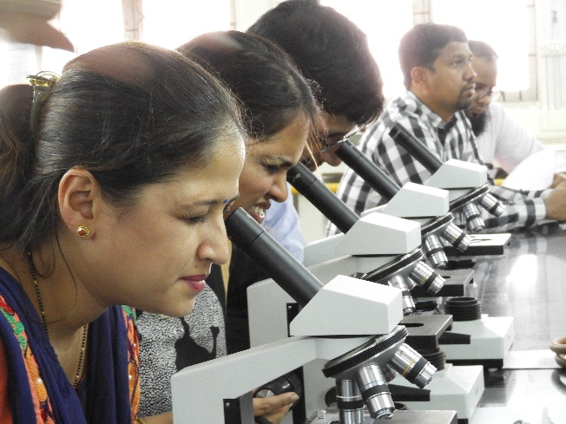
The post-lunch session was a hands-on training on Karyotype analysis conducted by Mr. N. K. Sharma. The participants were given images of different chromosomal spreads and explained the method of eye karyotyping which is the basic method of analysis. The participants were explained the process of making chromosome spreads and its staining method. They were also shown the pre-stained permanent slides with the chromosomal aberrations.
The first session of day two was conducted by Dr. Rita Muhkopadhyaya, BARC. She gave an overview of Radiation and Health. She focussed on the areas of natural and man-made radiations and stressed on the fact that natural radiation is not harmful and how living cells have devised methods to protect ourselves from the same. Dr. Mukhopadhyaya explained how the radiations from mobile phones or microwave ovens are non-ionizing in nature, and therefore are not damaging. The damage causing radiations are the ones that cause ionization.
The second session was on Cancer cytogentics and Molecular Genetics: Applications in diagnosis and disease management and the speaker was Dr. Pratibha Kadam Amare, Chief Cancer and Clinical Genetics, Lilac Insights Pvt. Ltd. In her talk she focussed on cancer cytogenetics and molecular genetics and the global attention it has gained in early cancer prediction, accurate diagnosis, treatment response and monitoring
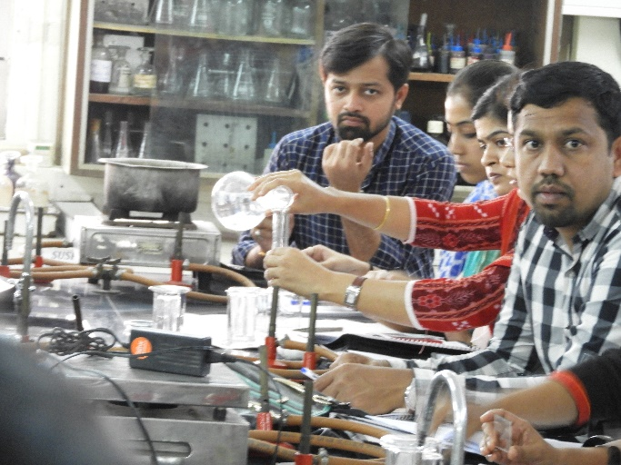
The third session was a hands-on practical session on Extraction of Human Exfoliative DNA from cheek cells. The participants extracted DNA from cheek cells. The DNA concentration and purity was checked by using UV spectrophotometry and its quality was assessed by Agarose Gel Electrophoresis (AGE).
The highlight of the day was the post visit to Lilac Insights lab at Airoli, Navi Mumbai. Born in September 2011, Lilac Insights is one of the India’s leading Genetic Health Assessment & Diagnostic Center. They are helping families & clinicians gain deeper insights to genetic conditions leading to better diagnoses for prenatal, new born & cancer disorders. The 30 participants were divide into four batches and each on rotation visited the labs viz. Cancer Cytogenetics lab, Cancer Molecular Genetics lab, Clinical Cytogenetics lab and Clinical Molecular Genetics lab. Interacting with the dynamic staff and observing the experiments and working of instruments made the day of the participants
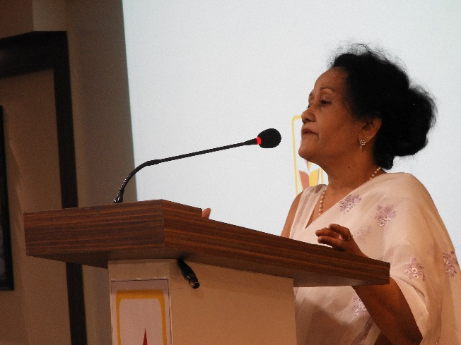
The third day started with a talk on ‘Advances in Human Genetics: From genes to genomics,’ by Dr. Vinay Jain, BARC. Dr. Jain’s talk was quite different from all the previous lectures as he brought the participants to look at individual genes and not chromosomes, and then to look at all genes that express together, genomics. His talk covered all recent technologies that have evolved in their post-Human Genome Project era.
The second talk of the day was by Dr. Anita Nadkarni, who talked about the genetics of haematological disorders. She covered all the conventional haematological disorders such as thalassemia and haemophilia. She detailed on all commonly founds variants of these diseases, the genetic reasons for the variations and how they are detected. She also touched upon the symptoms of the diseases and how difficult it is to diagnose a genetic disorder.
The practical session on day three involved two practicals; 18srRNA PCR of the DNA isolated on the previous day and DNA fingerprinting by RAPD (Random Amplified Polymorphic DNA). Both the practicals were possible because of kits purchased from HiMedia Pvt. Limited. The PCR machine used for the practicals was also purchased using the LTMT budget from HiMedia Pvt. Ltd.
The second lecture session of day three was delivered by Prof. S. Ganesh from IIT Kanpur. He spoke about ‘Complexitites in monogenic disorders.’ Prof. Ganesh has been working on a genetic disorder called Lafora Disease. Prof. Ganesh, in his talk demonstrated how monogenic disorders, that have been regularly used by genetics’ teachers to explain mendelian genetics, are not as simple as they seem to be.
The Valedictory Address was also given by Prof. S. Ganesh. In this session he talked about ‘Pedagogical tools in Human Genetics’. He explained the basic tricks he uses to keep his class of engineers at IIT, Kanpur engaged in a biology topic like genetics. He stressed about using as many examples as possible. The examples chosen to explain concept should be, he said, relatable. If the students relates to the concept being taught, he or she learns better.
Even though some important topics were not clearly outlined in the lectures, all speakers spoke about them. These include, ethics in doing research with human samples, genetic counselling and the responsibility that comes on the researchers when working with genetic disorders. Since the lectures involved teachers and student participants, the resource persons were kind enough to come down to the level of students not making them left out in the discussion and their presentation. All the participants were very happy with the variety in the lectures organised and also the practicals conducted. The participants were also made to take a short quiz every day, to understand their learning in the workshop.
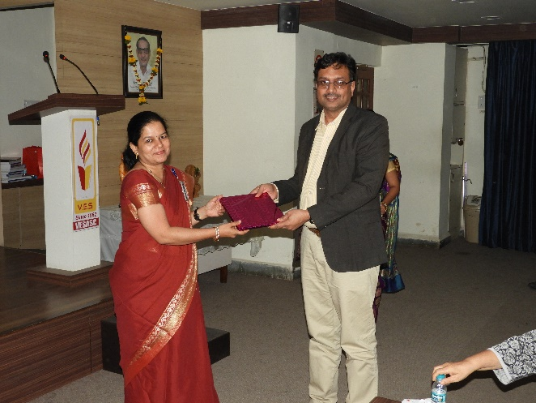
The three day teacher training workshop was jointly organised by the Departments of Microbiology and Biotechnology of Vivekanand Education Society’s College of Arts, Science and Commerce and sponsored by Lady Tata Memorial Trust (LTMT). The workshop was possible because of some successful associations with Lilac Insights, Navi Mumbai and HiMedia labs, Mumbai.

