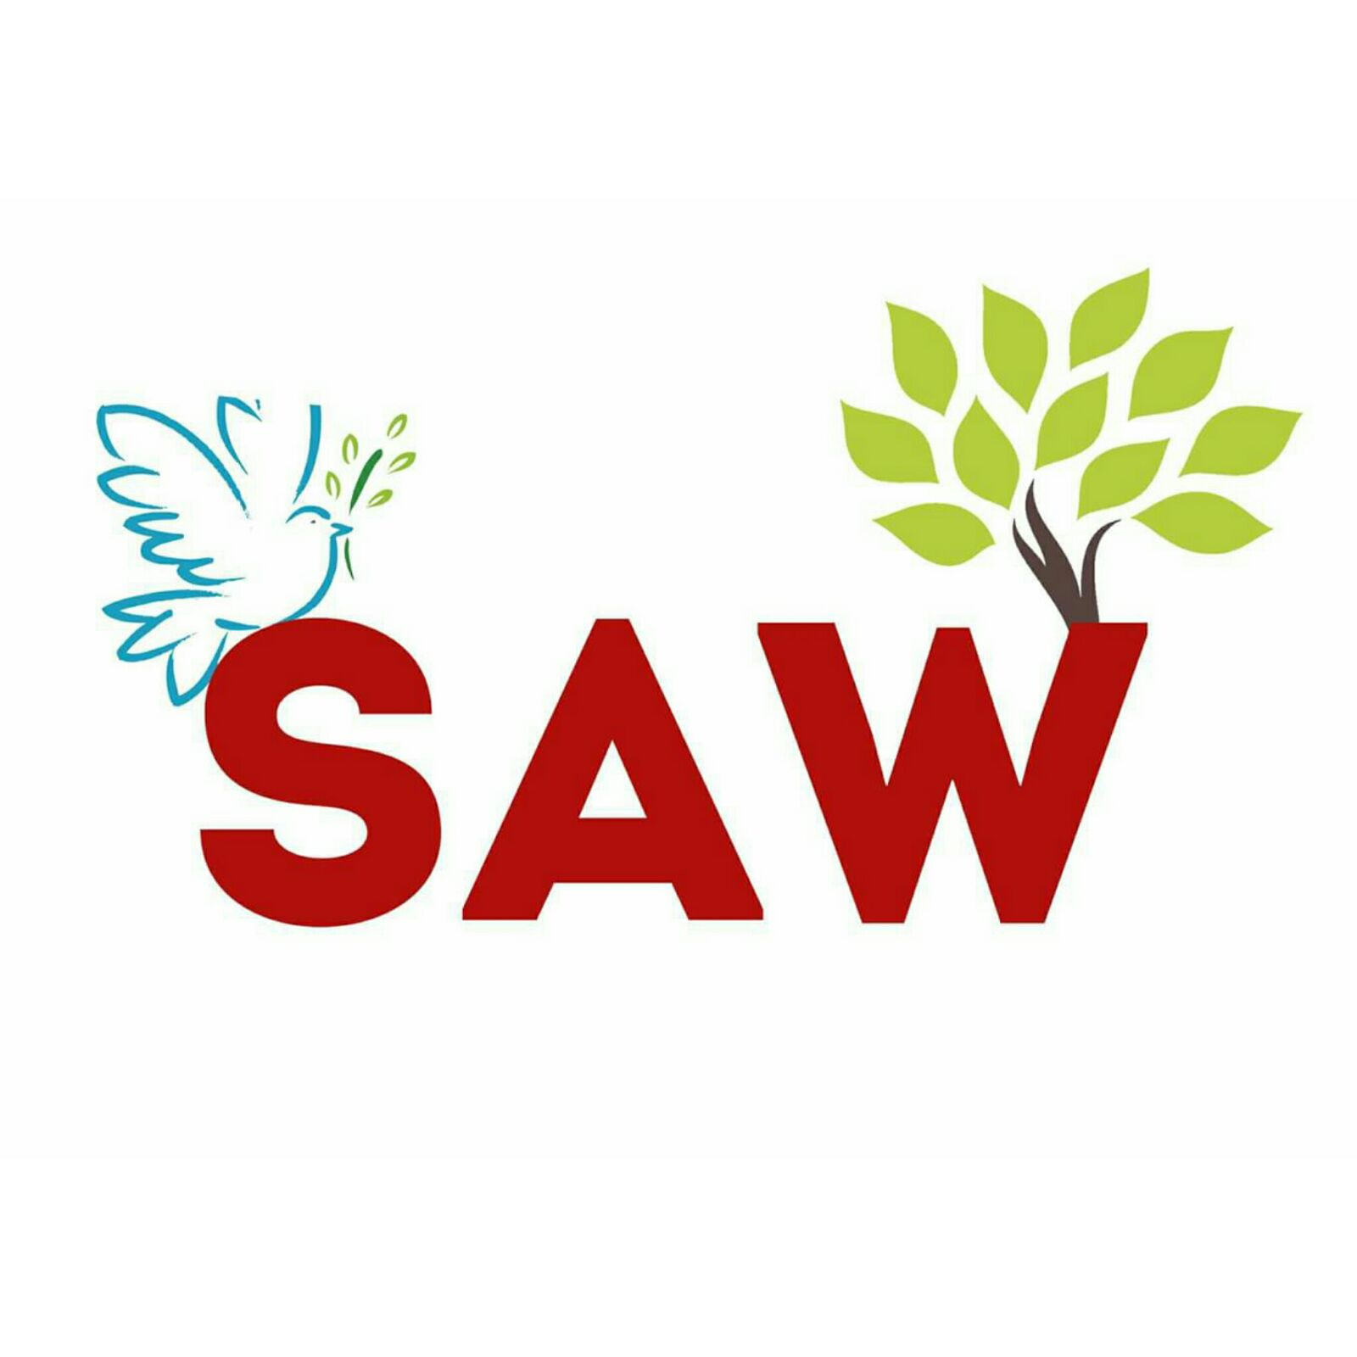
Objectives of SAW:

- To extend the knowledge with the community.

- Since 2007 Spreading Awareness amongst people about Social issues.

- Direct interaction by serving the community rather than stand alone theoretical knowledge with seminars, workshops, etc.

SAW 2016- 17 Overview:

DAY 1- A visit to 6 NGO's at three different locations around Mumbai.

DAY 2- Rally to spread awareness about social issues and Drop a Coin.

DAY 3- Spreading Awarness on topic of Voting.

DAY 4- Wet Waste Management and Decomposting at Tata Institute of Social Science.

DAY 5- Deaddiction Adventure Sports activity in association with Abhiyaan Foundation.

DAY 6- Fundraising activity at Mini Seashore, Vashi.

DAY 7- A visit to two leprosy villages in Trombay: Niramay Leprosy Center & Abhinav Gyan Mandir.

DAY 8- Organised blood donation and health checkup camp at VES College Campus.

DAY 9- Organized a cleanliness drive at Versova beach in association with Adv. Afroz Shah.

DAY 9- Visited Access Life NGO located at Ghatla Road, Chembur.

